**High Probability Swing Trade Setups In Bull Markets**

**The PD Arrav Matrix:**

Old High or Low Rejection Block Bearish Orderblock Fair Value Gap Liquidity Void Bearish Breaker

Bearish Mitigation Block

**Market Price**

Bullish M11tga1ton Block Bullish Breaker L1qu1d1ty Vmd

fair Value Gap Bullish Orderblock ReJecllon Block Old I OW or High

...

:::

g

i5

u

"'

**PD Array Matrix**

\\'hen dcfining the market conditions \\L' think in terms of,\hcr1.; the: Price

....-an n:a\.'h fnr. Both in a rally and in a lh:dinc. This i-. the foundation to determining likl'iy marh·t din.·ction.

l"hc PD Arrays that ha, L' b..:cn trad...·.d to lH. cxccutL'd on most n:ccntly

indicati.:- thL' opposite PD .-\nay spl.?ctrum will h(' reached for.

1rn1,cou111:\rr.i:s ha,c pnl\idcd Suppo11 ror PriL"l.' prohahilitic, ith.:r1,,.•as....• that till' f>n.·. mium Arr.1y-. will h1.· Sllll ht ah1l\ ..... th....• 111arkct pric •.

h:1\1..' pnn1d,..:d R...·.-,1-,[;!llL"i..' 11.ir Pn,.:1.· prt1h;1h1lit11,.•,

1rPrl'!llllllJ1.\rr1:,

t11L·r'-·;1..,'-· th.it I )1,<11u111 \n.1:, \\ ill bl· ,11u ht h,:l1i\\ th,: 111;1rk,:1 p111..-l·

We look for displacement bouncing from a discount array

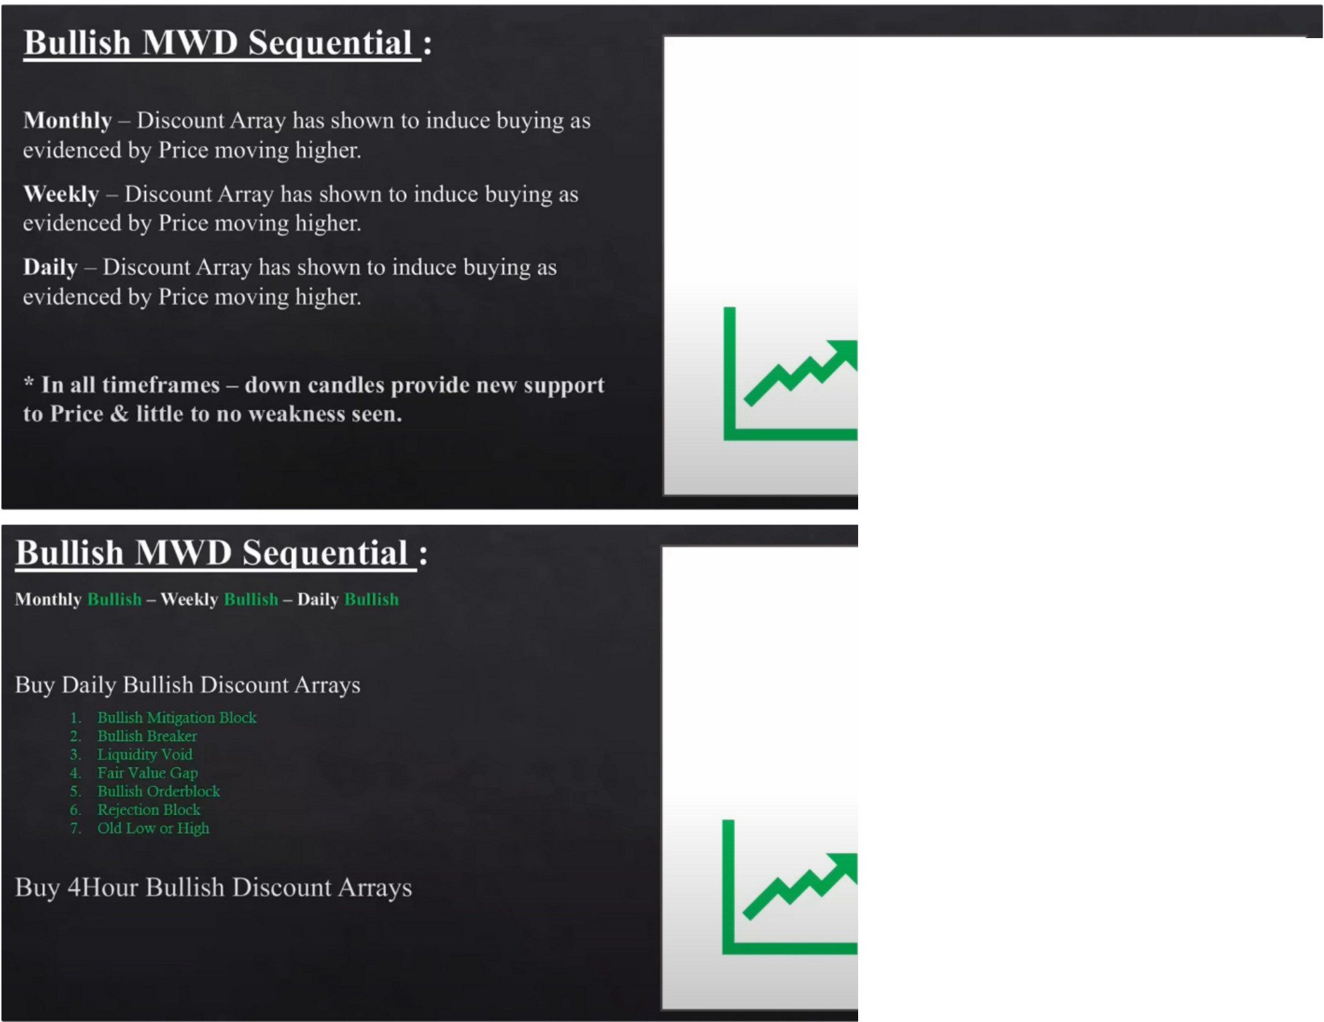

**Bullish PD Array Driven**

**Bullish PD Array Driven**

We buy all the discount arrays on the daily and 4h

He rounds the levels to institutional levels

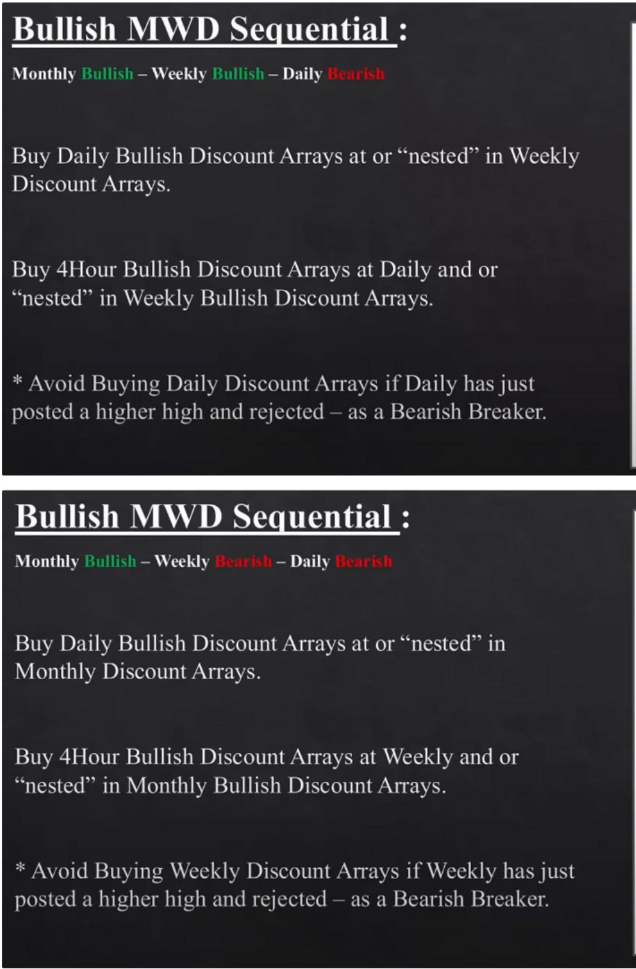

**1**

**Bullish PD Array Driven**

I **Bullish PD Array Driven**

Everytime daily trades back into a downcandle we can be a buyer, because we now have monthly and weekly in alignment. We waited for the monthly reference point to be hit first because the weekly and daily came back bearish

Were looking at levels, not zones. We use the open and the high

Now we move to the 4h executable timeframe with all the daily downcandles on it and we also add the 4h downcandles

Everytime ICT does his analysis he has indeed so many lines on his chart, he removes the old ones so he only has the most recent ones, but thats the main reason why he doesnt share his analysis chart.

Not only are we buying every downcandle were also buying below old short term lows

Thats why ICT expects lows to get ran sometimes before an upmove, because theres no orderblock to draw to or the orderblocks is already breached he expects the low to get ran, minute 27

* **1,UU. 11-'111.llll.1.111,t.!**

# ,111)

i,.1.$

.-.

.-.

-..

1il,.lll1!•t 11,.1111

"·

...

...

•

,I t ,

I'I ,

**t•H.**,•11l

."·.

...

11 1 , 111111

1

j,!!1!l'l1jl li't•I

I-!**11!11'1**

1 I ·....

.., ..

·-

.·.

_,..,.

These are the levels where you would expect a liquidity void to get filled, these are targets

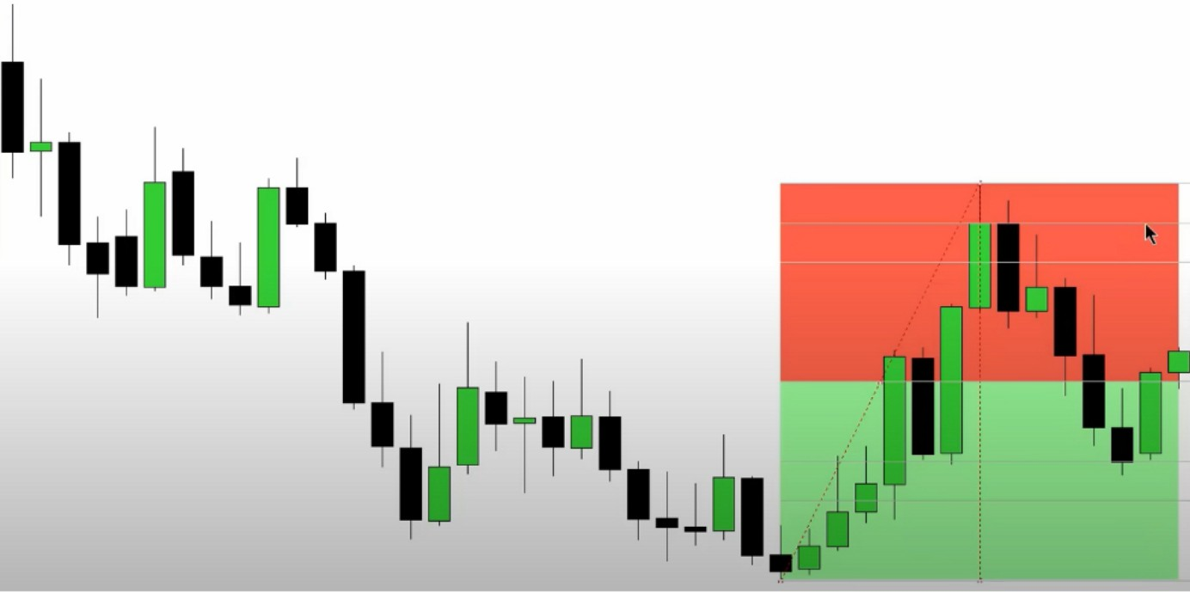

He doesnt like to see anything less than 20 in discount, ICT doesnt take longs in premium and no shorts in discount

E

.:E::J

,Q_)

0..

-

0

Q)

*Cl)*

*_::,::_*

0

:0,_

Q)

:::J

0

-

*Cl)*

C

-

..c

Q)

*Cl)*

-

Q)

..c

3

0



l l l

l ; l

l l

-->-

- D--

-c:::1-

-t-

-----

-------------

-

--

-

---

----

--

-------

----

--

---I

-

---=::-

----

---

---

---+-

-

---

---

--- ----+---

--

----

------

-

----

---

--+

--

-

-=--

-

---

-

---0-

---

---

=--c:::::!-

-

---=

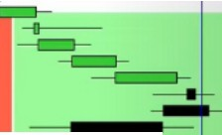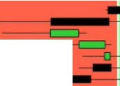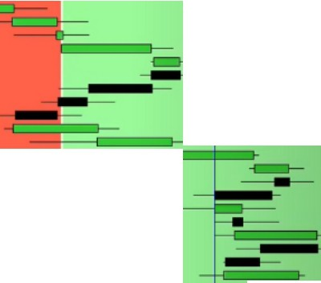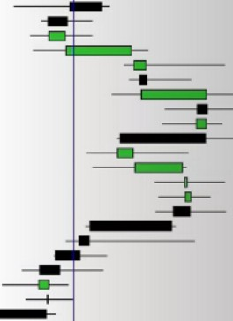

l l l

l ; l

l l

I l

-

------t- ----

---=

--

----

---

**-1111!11**■**--c::-===-:::,--·-**

---0-

-

---

-=--

,,,.

---

- -------

---

--

-----

-

---

----

--+-

-

---

"I:!

0

"cOu

.n

-

Q)

..c

Q)

:!::'.

.;::::

3

-

0

..c

cu

*_::,::_*

0

0

J

cu

"O

-

0

"O

0

0

0)

*Cl)*

0)

C

C C

0)

Q)

.n

-

Q)

..c

C

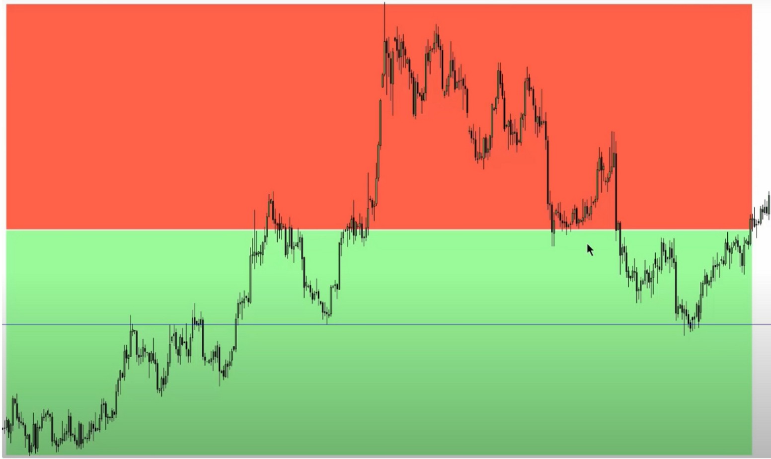

See how the bearish orderblocks are good in premium

We want to see the bearish orderblocks get broken in discount, and all the upcandles Swing trades are very rule based, daytrades can be ambigious

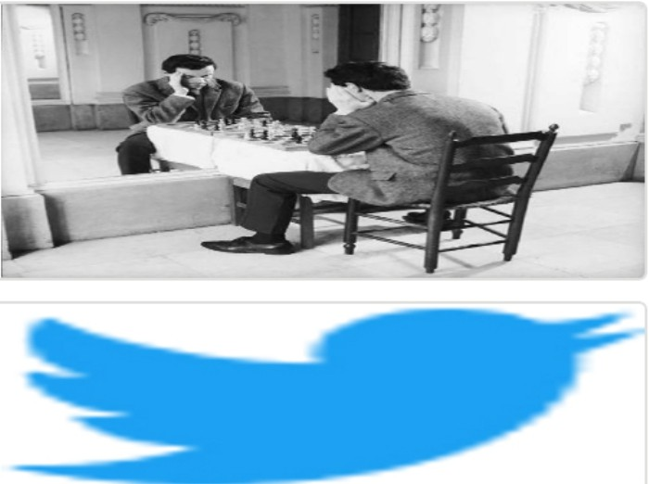Arjo I Twitter, lnstagram I Linktree

Linktree. Make your link do more.

1 https://t.co/HhmmTN1fUI

JavaScript is not available.

*"'!I* https://twitter.com/arjoio